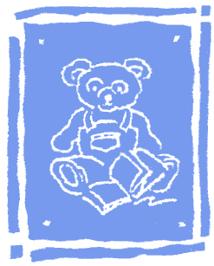

CHELSEA DAY SCHOOL

319 Fifth Avenue
New York, NY 10016
Telephone: (212) 675-8541
Fax: (212) 675-8385

PERMISSION TO RELEASE RECORDS
Dear Parents,

Kindly sign and fill out the form below indicating the schools that you are applying your child to for the 2022-2023 school year.
I give permission to Chelsea Day School to release copies of the requested student records to all schools listed below.

________________________________
Signature of Parent or Guardian

Name of Student: ___________________________ Applying to Grade __________

Name of School | Due Date

